

YEONTANDER PROVIDER

Group 5

Names : Juana Lucia Raharusun

Muhamad Farhan Aldisyah Putra

Pratistha Cahya Kancana

Class : 2SC4

CEP CCIT

FAKULTAS TEKNIK UNIVERSITAS INDONESIA

2021

**Developed by**

1. **Juana Lucia Raharusun**
2. **Muhamad Farhan Aldisyah Putra**
3. **Pratistha Cahya Kancana**



**PROJECT ON**

*Yeontander Provider*

**Yeontander Provider**

Batch Code : 2SC4

Start Date : Friday, June 18th, 2021   
End Date : Friday, July 2nd , 2021

Name of Faculty : Kevin Harada

Names of Developer :

1. Juana Lucia Raharusun
2. Muhamad Farhan Aldisyah Putra
3. Pratistha Cahya Kancana

Date of Submission: Sunday, July 4th , 2021

**CERTIFICATE**

This is to certify that this report titled “Yeontander Provider” embodies the original work done by Juana Lucia Raharusun, Muhamad Farhan Aldisyah Putra and Pratistha Cahya Kancana. Project in partial fulfillment of their course requirement at NIIT.

Coordinator:

Kevin Harada



**ACKNOWLEDGEMENT**

First of all, we would like to thank God because of His blessings and guidance, writers can compose and present a paper that contains about Implementation of Information Technology in an apartment, as one of IT Introductory lecture. The writer also thanked to Mr. Kevin Harada as lecturer Introductory IT course that have provided guidance to the writer in the process of preparing this paper. Not to forget the writer thank the various parties who have given encouragement and motivation

The author realizes that the preparation of this project there are still many shortcomings and far from being perfect. Therefore, the authors expect constructive criticism and suggestion to improve this paper and can be reference in preparing the papers or subsequent tasks.

The authors also apologize if in writing this paper there are typos and errors that confuse the reader in understanding the author’s intent.

Jakarta, June 18th , 2021

**SYSTEM ANALYSIS**

**System Summary**:

An internet provider is a service provider that provides internet connection services in the field of cellular telecommunications. The use of the internet can be said to be one of the important needs for some people. With any internet access becomes easier. This website was created to make it easier for customers to purchase credit and internet packages.

To make the website look more attractive and presentable, we use CSS that is connected to the HTML page. This makes the appearance of the website and the components in it more attractive and orderly.

**INTRODUCTION**

This project is about creating a website that we named Yeontander Provider. This website is made for people who want to buy credit and quota packages online without any hassle and we also provide internet service with great and stable speed.

\

sssssssssss

**ACTIVITIES LIST**

In our Yeontander Website, customers can choose available credit or internet packages and there are also tips and tricks to save quota.

1. **Sign Up & Sign In**

If the customer does not have an account, the customer must first create an account at the sign-up section. If you already have an account, the customer can immediately sign-in to enter the Yeontander page.

1. **Home**

On the Home Page the customer will see a brief description of Yeontander and there will be several sections such as:

* Isi Pulsa : There are 4 choices of pulses ranging from 5K to 100K with the benefits of each option.
* Kuota : There are 4 choices of quota packages ranging from 5GB to 50GB for 30 days with each special access given to each package.
* Tips & Tricks : There are several tips to save credit and quota for customers
* Contact Us : There is Yeontander's contact info and fields to fill in the criticism or suggestions customer want to convey.

1. **Payment**

After selecting the credit or quota package to be purchased, the customer will make a payment via Ovo or Gopay.

**HTML PAGES**

1. Sign in & Sign Up

Customers who already have an account can directly login by entering their username, phone number, and password.

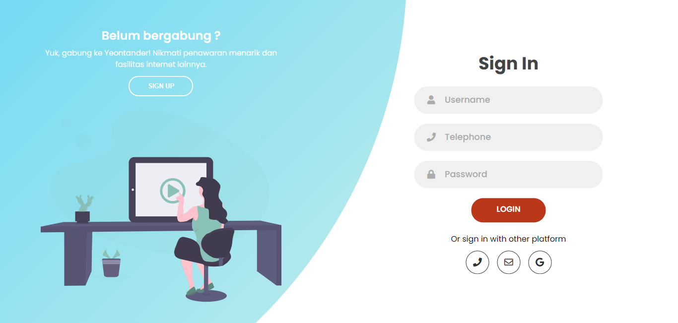

Meanwhile, for those who do not have an account, you can create an account first by entering your username, email, and password.

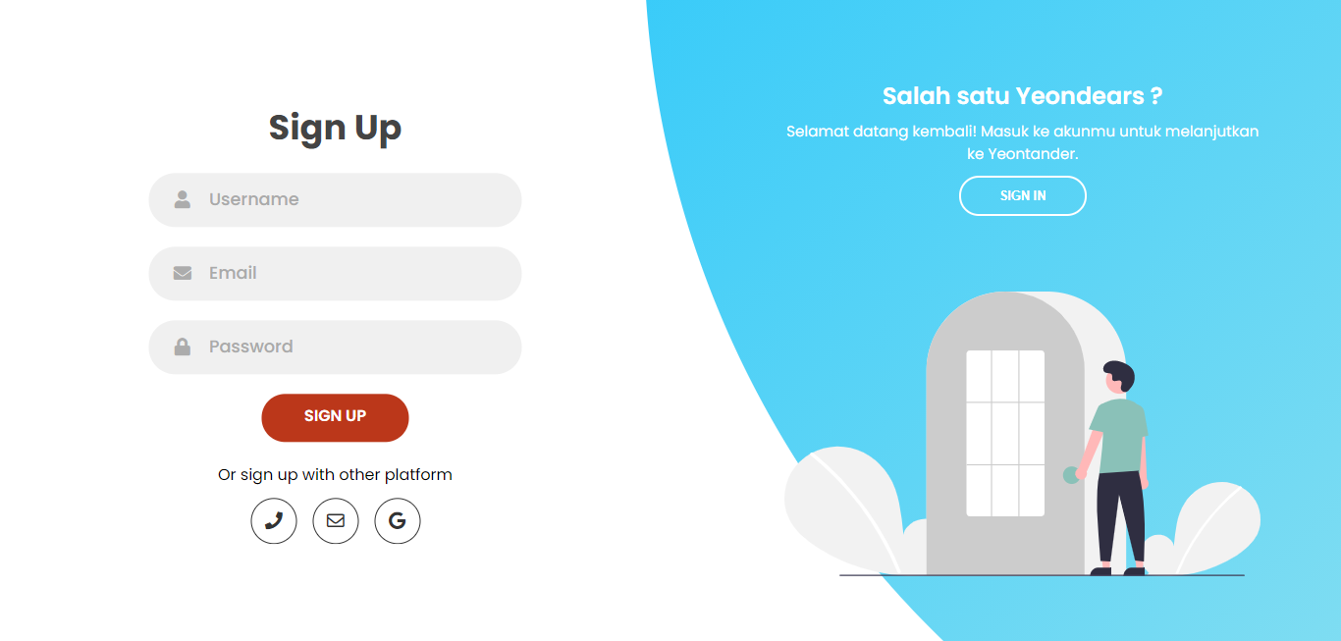

**HTML PAGES**

2. Home

There is a navigation consisting of 6 sections in the menu bar and a brief description of Yeontander Provider

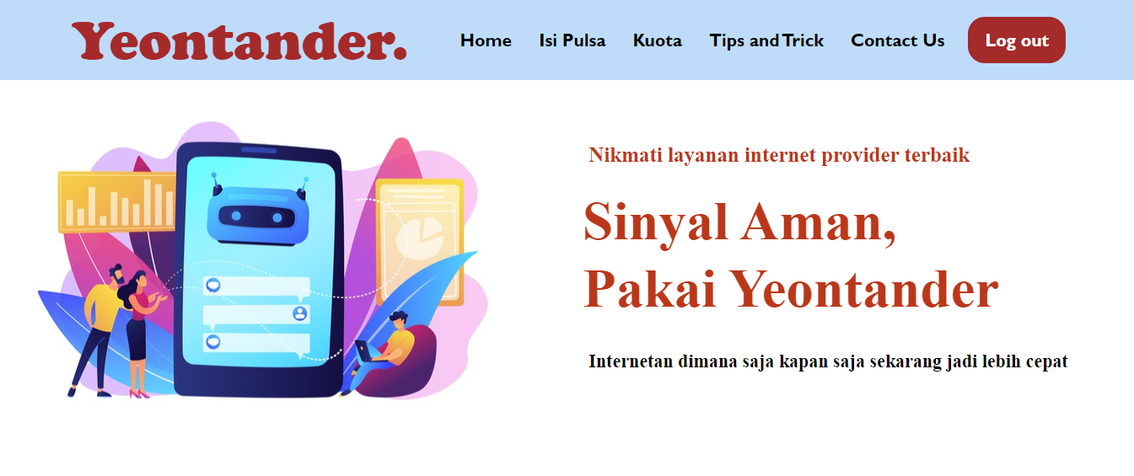

* Isi Pulsa

We provide 4 credit options namely Irit Bingit, Ga Pelit, Banyak Duit, and Sultan Nih. With the advantages of each option and there is a button that will lead to the payment form.

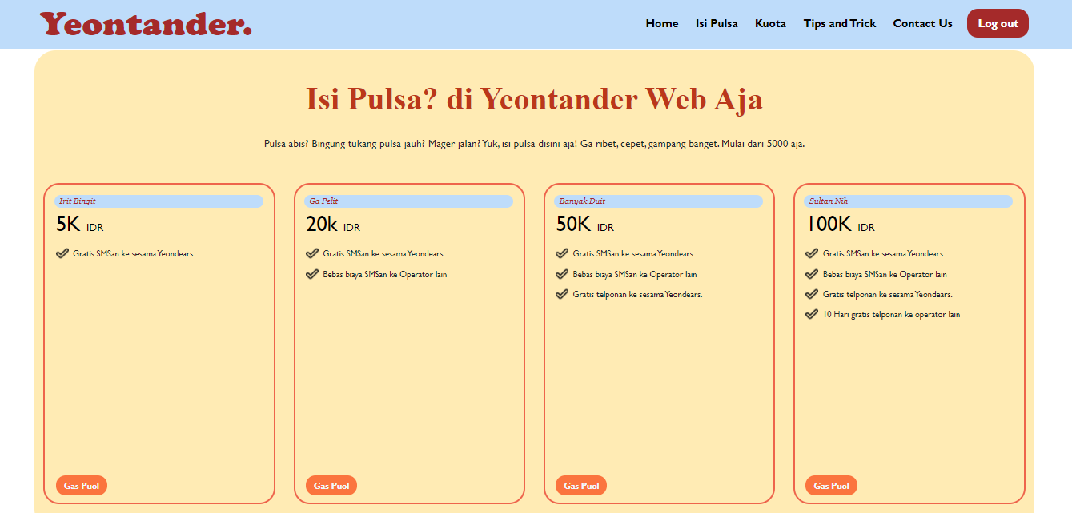

**HTML PAGES**

* Kuota

In the Kuota section there are also 4 options with the benefits of each choice. There are 4 quota packages: Kuota Kanker, Kuota Anak Kost, Kota Baru Gajian, dan Kuota Anak Konglomerat. After selecting, the customer can click the button that will lead to the payment form.

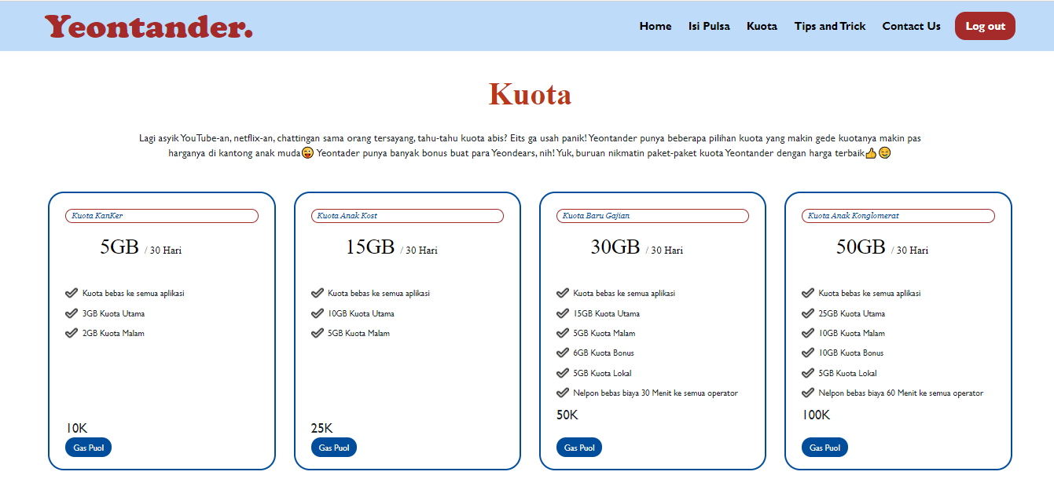

**HTML PAGES**

* Tips & Tricks

Yeontander provides some tips that will be useful for customers.

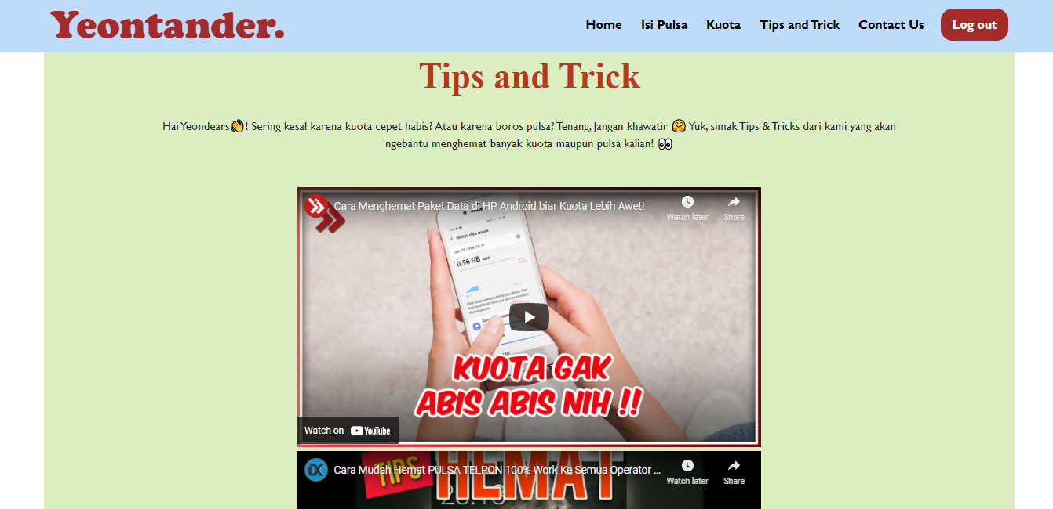

* Contact Us

To make it easier for customers to submit criticisms and suggestions, we provide a special field for that. We also include an email and telephone that can be contacted by customers.

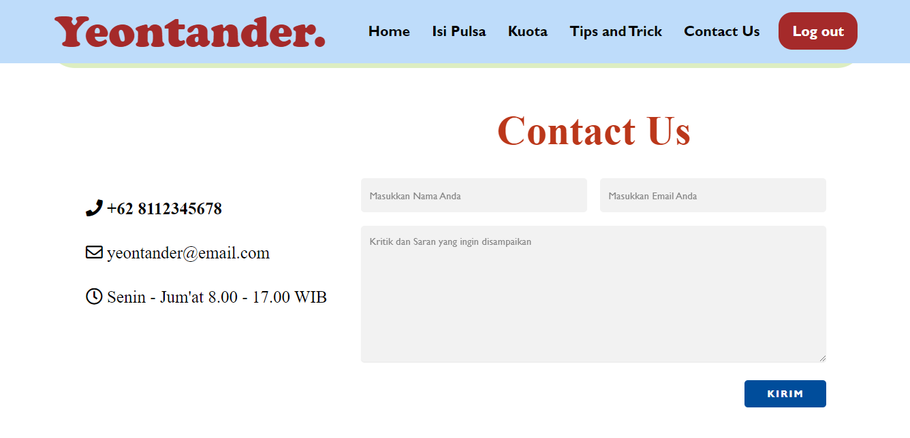

**HTML PAGES**

3. Payment

In the form the customer needs to fill in the phone number and needs to choose a payment method. The price to be paid will also appear according to the credit/quota package selected by the cutomer.

* Payment Pulsa

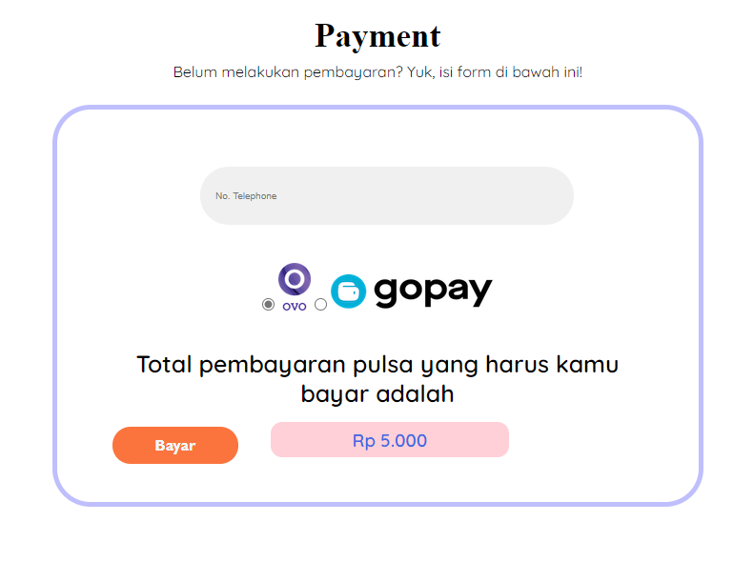

* Payment Paket Kuota

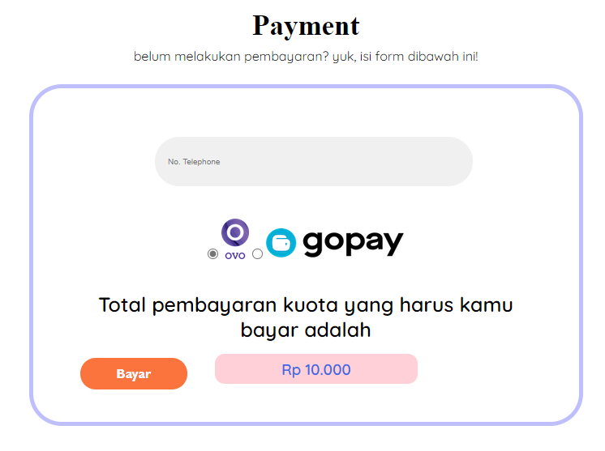

**CONFIGURATION**

**Hardware :** Hp 14-bs704TU

**Operating System :** Windows 10 Home

**Software :** Microsoft Office Word, Microsoft Office Power Point, VisualCode

Studio

|  |  |  |
| --- | --- | --- |
| **PROJECT FILE DETAILS** | | |
| **S.No** | **File Name** | **Remarks** |
| 1 | Yeontander Internet Provider_Group 5.docx | Paper |
| 2 | Yeontander Internet Provider_Group 5.pptx | Slideshow |
| 3 | signupform.html | HTML |
| 4 | Yeontander Internet Provider.html | HTML |
| 5 | formpulsa.html | HTML |
| 6 | formkuota.html | HTML |
| 7 | stylesign.css | CSS |
| 8 | style yeontander.css | CSS |
| 9 | stylepulsa.css | CSS |
| 10 | jssign.jss | JSS |